Unit 5
Virtualization and Containerization Technology

(8 Hours)

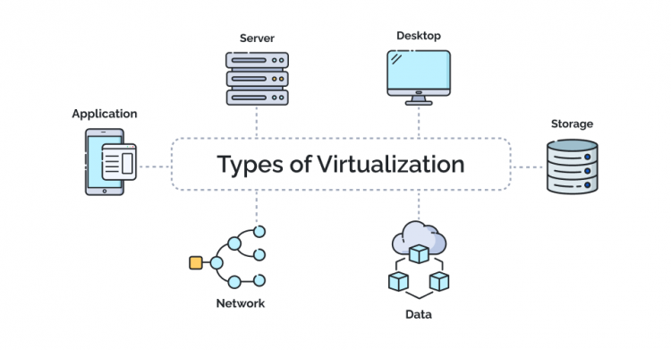
. 5.1 Introduction to virtualization
. 5.2 Types of virtualization:
. Server virtualization
. Storage virtualization
. Network virtualization
. 5.3 Virtualization architecture and implementation
. 5.4 Hypervisors and types
. 5.5 Virtual machine lifecycle
. 5.6 Introduction to containerization
. 5.7 Virtual Machine vs Container
. 5.8 Introduction to serverless computing
. 5.9 Event-driven functions
. 5.10 Load balancing concepts
. 5.11 Serverless vs containerized workloads

. 5.1 Introduction to virtualization

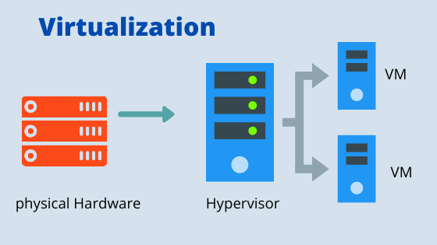
Meaning of Virtualization
Virtualization is a technology that allows one physical computer/server to act like multiple separate computers.
Each virtual computer is called a Virtual Machine, commonly known as VM.
A virtual machine has its own:
. Operating system
. CPU allocation
. RAM allocation
. Storage
. Network interface
. Applications
But physically, all VMs run on the same hardware.

Simple Example
Suppose one physical server has:
Resource | Capacity
CPU | 16 cores
RAM | 64 GB
Storage | 2 TB
Network | 1 Gbps

Using virtualization, we can create multiple virtual machines:
VM Name | CPU | RAM | Storage | Purpose
VM-1 | 4 cores | 16 GB | 500 GB | Web Server
VM-2 | 4 cores | 16 GB | 500 GB | Database Server
VM-3 | 2 cores | 8 GB | 250 GB | Testing Server
VM-4 | 2 cores | 8 GB | 250 GB | File Server
So, instead of buying 4 separate physical servers, we use one powerful server and divide it virtually.

Real-Life Analogy
Virtualization is like dividing one large building into many separate apartments.
The building is the physical server.
Each apartment is a virtual machine.
Each apartment has its own room, door, electricity, and users, but all are inside the same physical building.

Why Virtualization is Needed
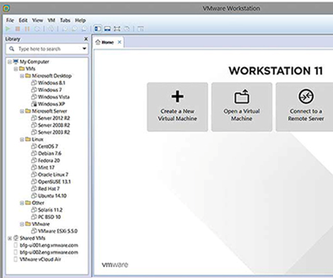
Before virtualization, many organizations used one server for one application.
Example:
. One physical server for website
. One physical server for database
. One physical server for email
. One physical server for file sharing
This caused:
. High hardware cost
. Low resource utilization
. More electricity use
. More cooling requirement
. Difficult maintenance
With virtualization:
. One server can run multiple systems
. Hardware is used efficiently
. Cost is reduced
. Backup and recovery become easier

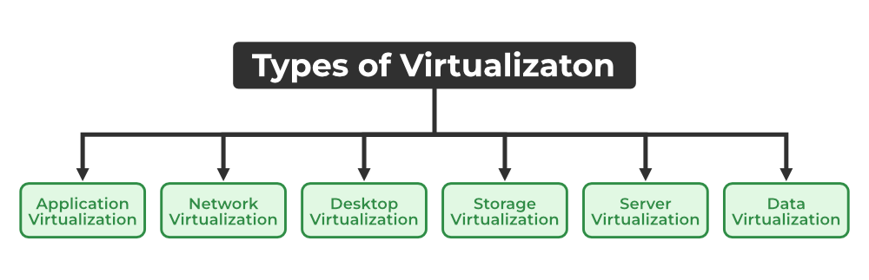
. 5.2 Types of virtualization:
. Server virtualization . Storage virtualization . Network virtualization

There are different types of virtualization.
Main types:
. Server virtualization
. Storage virtualization
. Network virtualization
. Desktop virtualization
. Application virtualization
According to syllabus, we focus mainly on server, storage, and network virtualization.

A. Server Virtualization
Meaning
Server virtualization means dividing one physical server into multiple virtual servers.
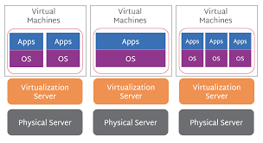
Each virtual server runs independently.

Example
A college has one physical server:
Physical Server Resource | Capacity
CPU | 24 cores
RAM | 128 GB
Storage | 4 TB
It can be divided into:
Virtual Server | CPU | RAM | Storage | Use
VM-Web | 4 cores | 16 GB | 500 GB | College Website
VM-LMS | 6 cores | 32 GB | 1 TB | Moodle / LMS
VM-DB | 8 cores | 48 GB | 1 TB | Database
VM-Backup | 4 cores | 16 GB | 1 TB | Backup Server

Benefits of Server Virtualization
. Reduces hardware cost
. Improves server utilization
. Easy backup and migration
. Easy testing and development
. Better disaster recovery

B. Storage Virtualization
Meaning
Storage virtualization combines multiple physical storage devices into one logical storage system.
Users see one storage system, but behind it, data may be stored across many disks or storage servers.

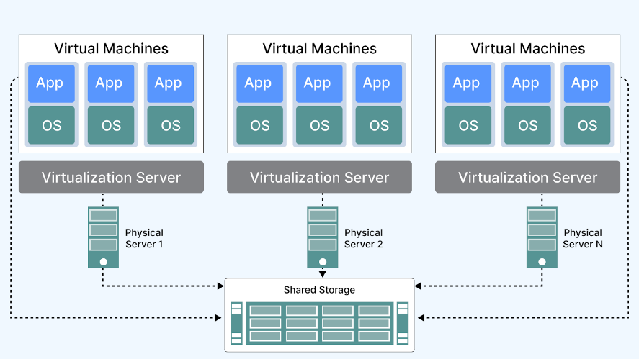
Example
Suppose a company has three storage devices:
Storage Device | Capacity
Disk Array 1 | 2 TB
Disk Array 2 | 3 TB
Disk Array 3 | 5 TB
Using storage virtualization, these are combined into one logical storage pool:
Total Virtual Storage = 2 TB + 3 TB + 5 TB = 10 TB
Users only see:
Company Storage Pool = 10 TB

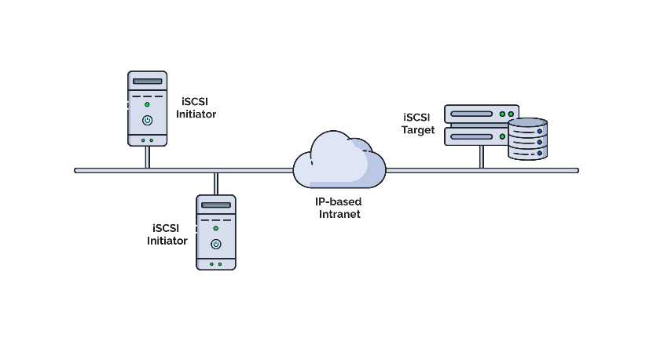

Data-Based Example
A hospital stores the following data:
Data Type | Storage Required
Patient records | 1 TB
Lab reports | 2 TB
X-ray and scan images | 4 TB
Backup data | 3 TB
Total storage needed:
1 TB + 2 TB + 4 TB + 3 TB = 10 TB
Instead of managing separate disks manually, storage virtualization provides one central 10 TB storage pool.

Benefits of Storage Virtualization
. Centralized storage management
. Better storage utilization
. Easy backup
. Easy expansion
. Improved data availability

C. Network Virtualization
Meaning
Network virtualization means creating virtual networks using software instead of depending only on physical network devices.
It allows multiple logical networks to run on the same physical network infrastructure.

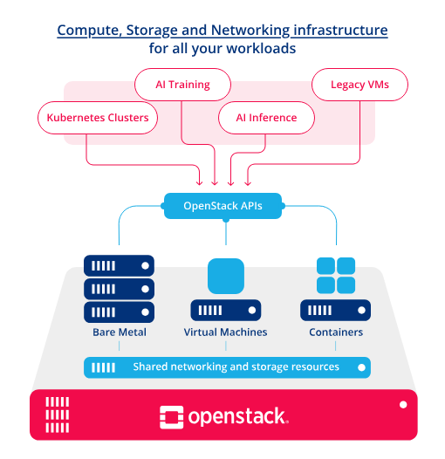
Example
A college has one physical network but wants to separate departments:
. Admin Network
. Teacher Network
. Student Network
. Guest Wi-Fi Network
. Lab Network
Using network virtualization, we can create VLANs or virtual networks.

VLAN-Based Example
Department | VLAN ID | IP Network
Admin | 10 | 192.168.10.0/24
Teachers | 20 | 192.168.20.0/24
Students | 130 | 192.168.30.0/24
Guest Wi-Fi | 40 | 192.168.40.0/24
Lab | 50 | 192.168.50.0/24
Although all departments may use the same physical switch, their traffic is separated logically.

Benefits of Network Virtualization
. Better security
. Logical separation of users
. Easier network management
. Supports cloud networking
. Reduces dependency on physical devices

. 5.3 Virtualization architecture and implementation

Basic Virtualization Architecture
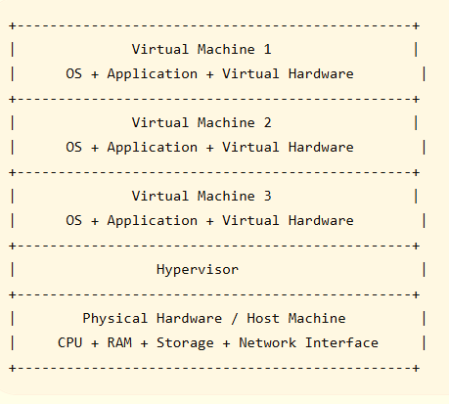

Main Components of Virtualization Architecture
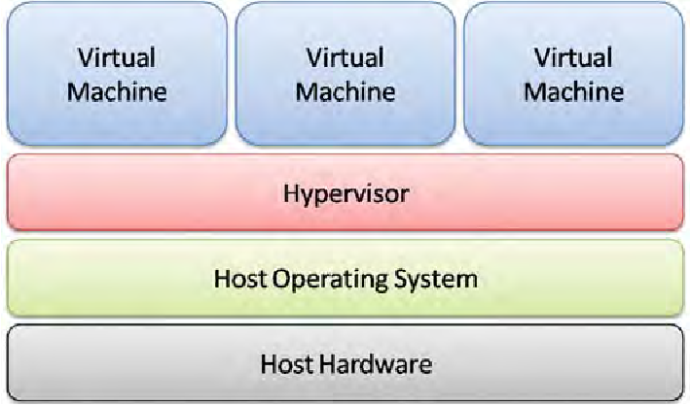
1. Host Machine
The physical computer or server where virtualization is installed.
Example:
A Dell, HP, Lenovo, or custom-built server with CPU, RAM, storage, and network card.

2. Hypervisor
The software layer that creates and manages virtual machines.
Examples:
. VMware ESXi
. Microsoft Hyper-V
. KVM
. VirtualBox
. Proxmox VE

3. Guest Machine
The virtual machine running inside the host.
Each guest machine may have its own operating system.
Example:
. Ubuntu VM
. Windows Server VM
. Kali Linux VM
. CentOS VM

4. Virtual Hardware
Virtual hardware is the simulated hardware given to each VM.
Examples:
. Virtual CPU
. Virtual RAM
. Virtual Hard Disk
. Virtual Network Adapter
. Virtual Display
Implementation Example
Assume we have one server:
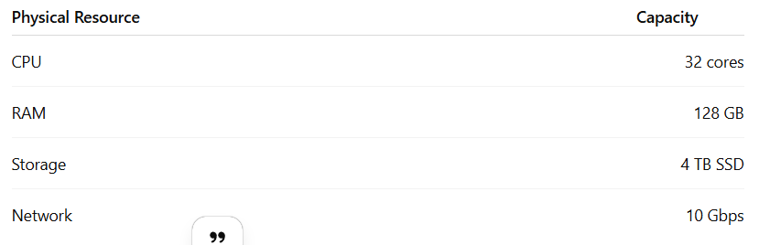
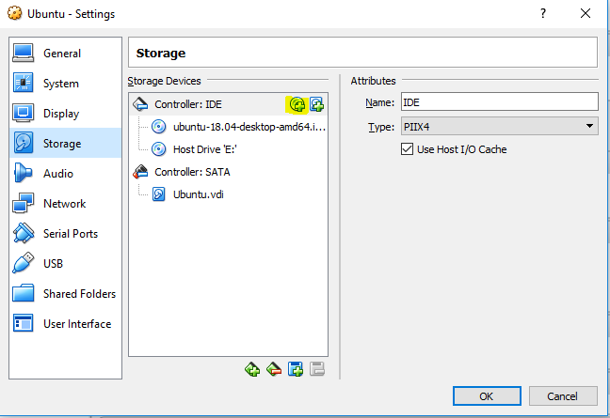

We want to create 5 VMs:
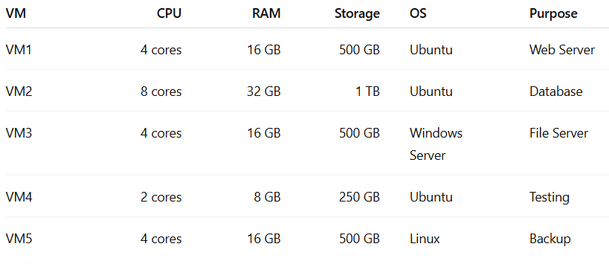
Total allocated:
CPU = 4 + 8 + 4 + 2 + 4 = 22 cores
RAM = 16 + 32 + 16 + 8 + 16 = 88 GB
Storage = 500 + 1000 + 500 + 250 + 500 = 2750 GB
Remaining:
CPU = 32 - 22 = 10 cores
RAM = 128 - 88 = 40 GB
Storage = 4000 - 2750 = 1250 GB
This remaining resource can be used for future VMs.

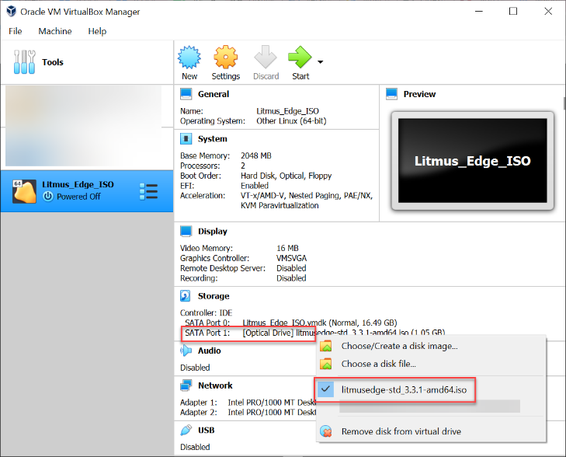

. 5.4 Hypervisors and types

Meaning of Hypervisor
A hypervisor is software that creates, runs, and manages virtual machines.
It controls how physical resources are shared among VMs.

Types of Hypervisors
There are two main types:
. Type 1 Hypervisor
. Type 2 Hypervisor

A. Type 1 Hypervisor
Meaning
A Type 1 hypervisor runs directly on physical hardware.
It does not need a host operating system.
It is also called a bare-metal hypervisor.

Architecture
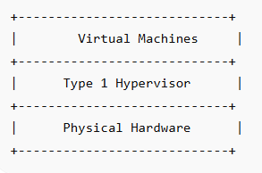

Examples
. VMware ESXi
. Microsoft Hyper-V Server
. KVM
. Xen
. Proxmox VE

Use Case
Used in:
. Data centers
. Cloud platforms
. Enterprise servers
. Production environments

Advantages
. High performance
. Better security
. Better resource control
. Suitable for production

B. Type 2 Hypervisor
Meaning
A Type 2 hypervisor runs on top of an existing operating system.
It is also called a hosted hypervisor.

Architecture
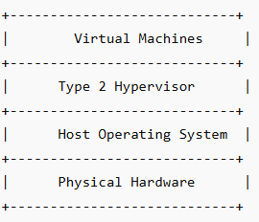

Examples
. Oracle VirtualBox
. VMware Workstation
. VMware Fusion
. Parallels Desktop

Use Case
Used in:
. Learning
. Testing
. Development
. Running Linux inside Windows
. Running Windows inside Mac

Advantages
. Easy to install
. Good for students
. Good for labs
. No dedicated server required

Type 1 vs Type 2 Hypervisor
Feature | Type 1 Hypervisor | Type 2 Hypervisor
Runs on | Direct hardware | Host operating system
Performance | High | Medium
Security | Better | Lower than Type 1
Use | Production, data center | Learning, testing
Examples | ESXi, Hyper-V, KVM | VirtualBox, VMware Workstation
Cost | May need dedicated server | Can run on laptop

. 5.5 Virtual machine lifecycle

Meaning
Virtual machine lifecycle means all stages from creating a VM to deleting it.

VM Lifecycle Stages
1. Planning
2. Creation
3. Configuration
4. Installation
5. Running
6. Monitoring
7. Snapshot / Backup
8. Migration
9. Scaling
10. Shutdown / Suspend
11. Deletion

VM Lifecycle Diagram
Plan VM Requirement
↓
Create VM
↓
Allocate CPU, RAM, Storage
↓
Install Operating System
↓
Install Applications
↓
Run VM
↓
Monitor Performance
↓
Backup / Snapshot
↓
Update / Migrate / Scale
↓
Shutdown or Delete VM

Example: VM Lifecycle in College Lab
Step 1: Planning
Requirement:
Need one Ubuntu VM for cloud computing practical.
Step 2: Create VM
Create a VM in VirtualBox.
Step 3: Allocate Resources
Resource | Value
CPU | 2 cores
RAM | 4 GB
Storage | 40 GB
OS | Ubuntu Linux
Step 4: Install OS
Install Ubuntu ISO file.
Step 5: Install Software
Install:
sudo apt update
sudo apt install nginx docker.io -y
Step 6: Run Services
Start web server:
sudo systemctl start nginx
Step 7: Monitor
Check CPU and memory:
top
free -h
df -h
Step 8: Snapshot
Take snapshot before risky changes.
Step 9: Shutdown
sudo shutdown now
Step 10: Delete
Remove VM when no longer needed.

Proxmox Screenshot
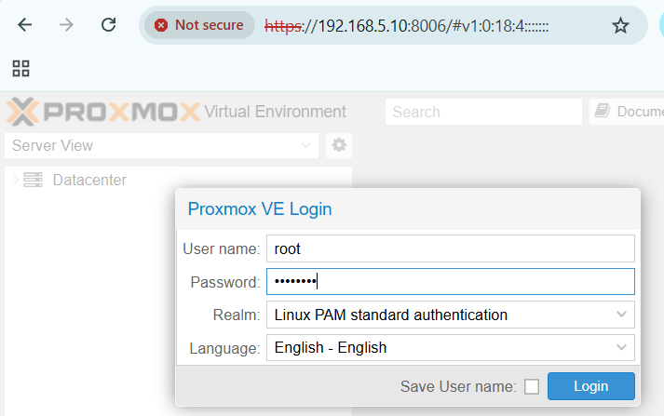

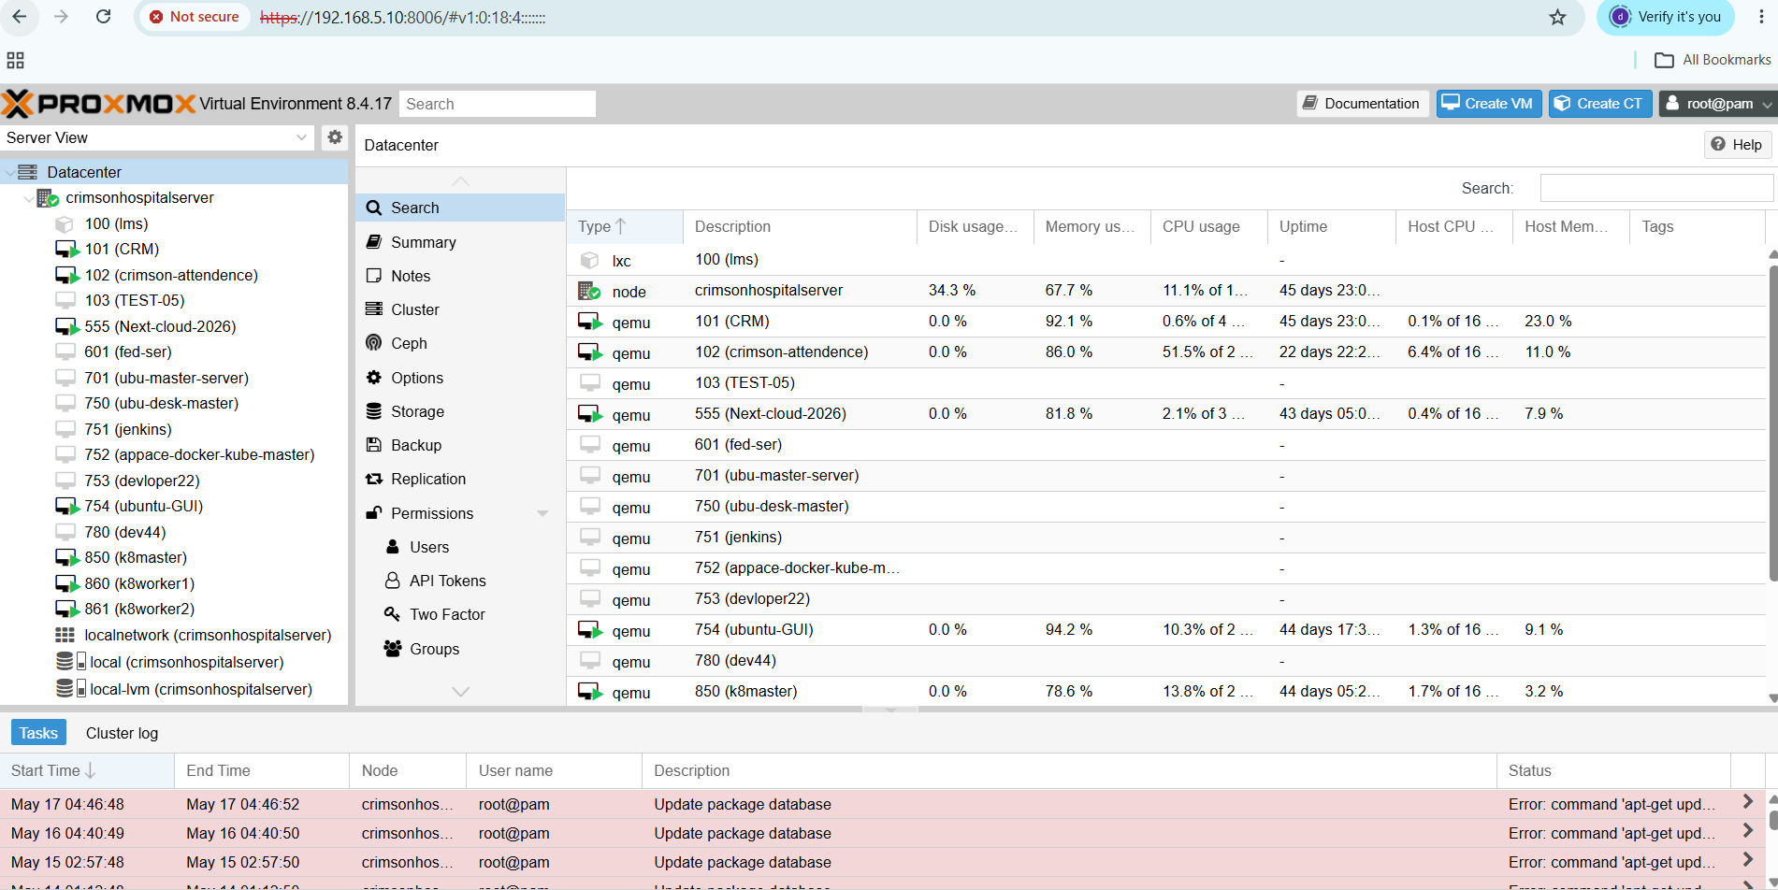

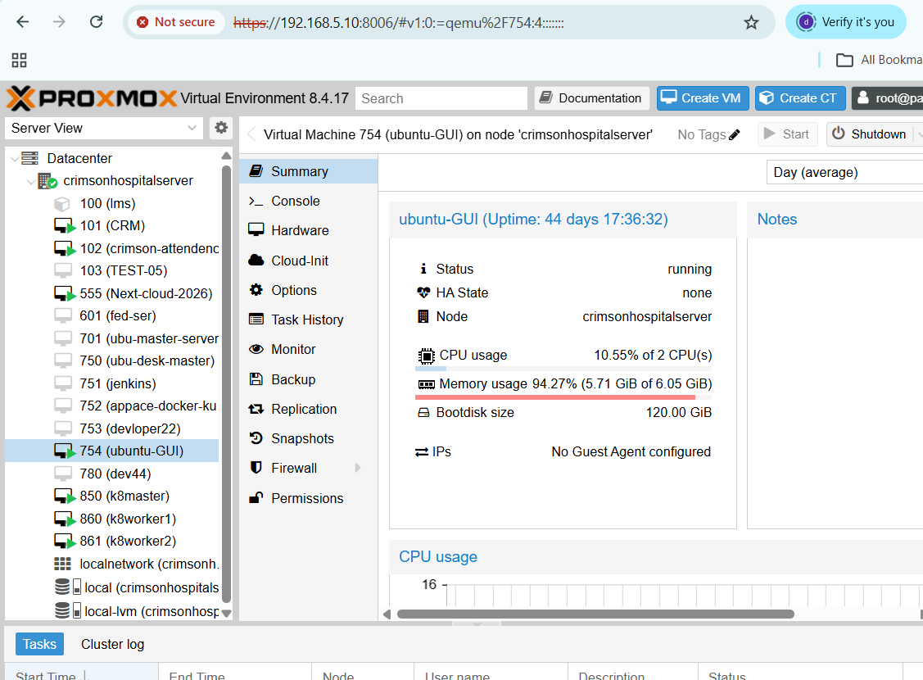

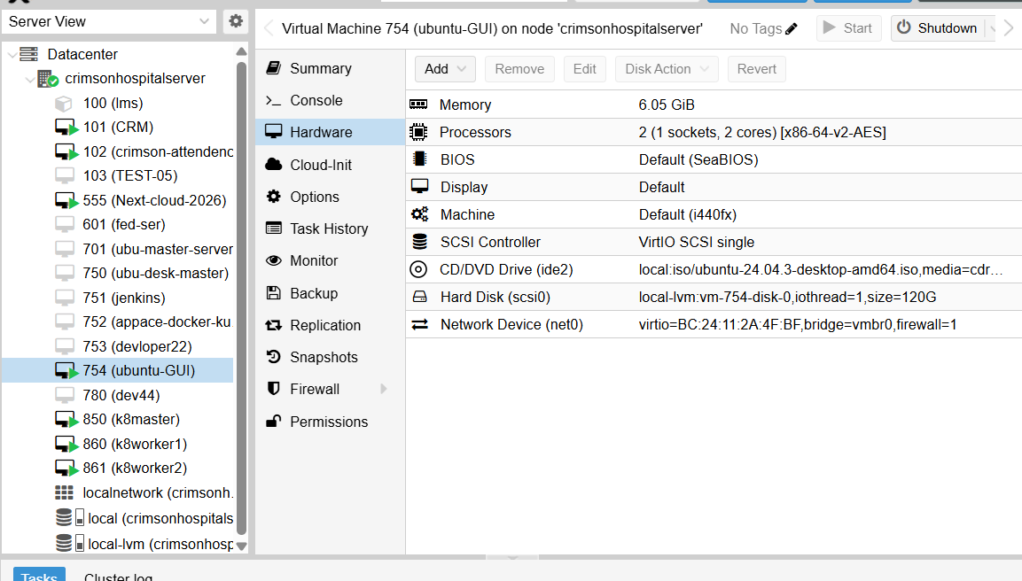

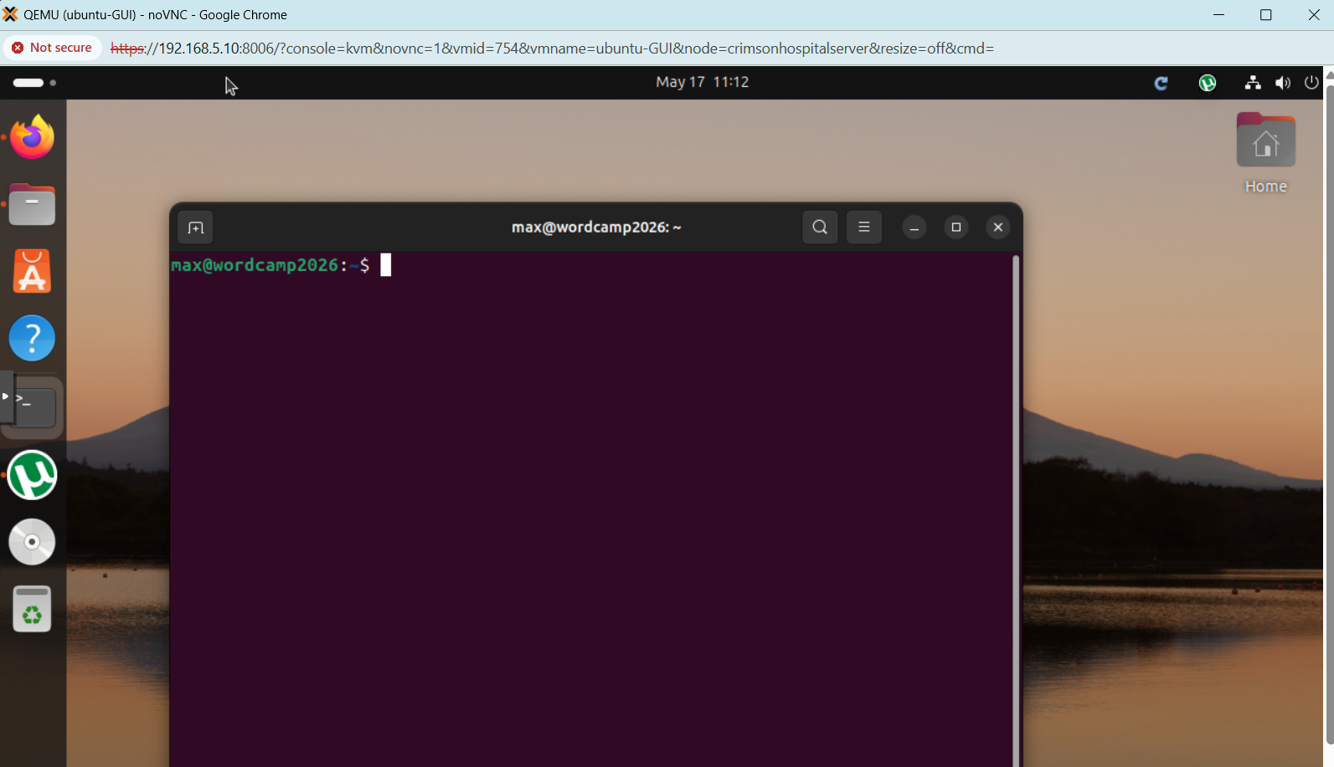

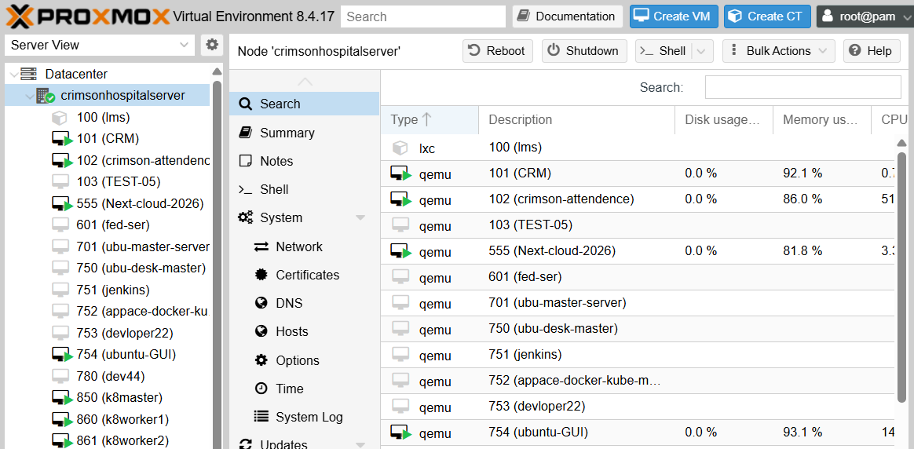

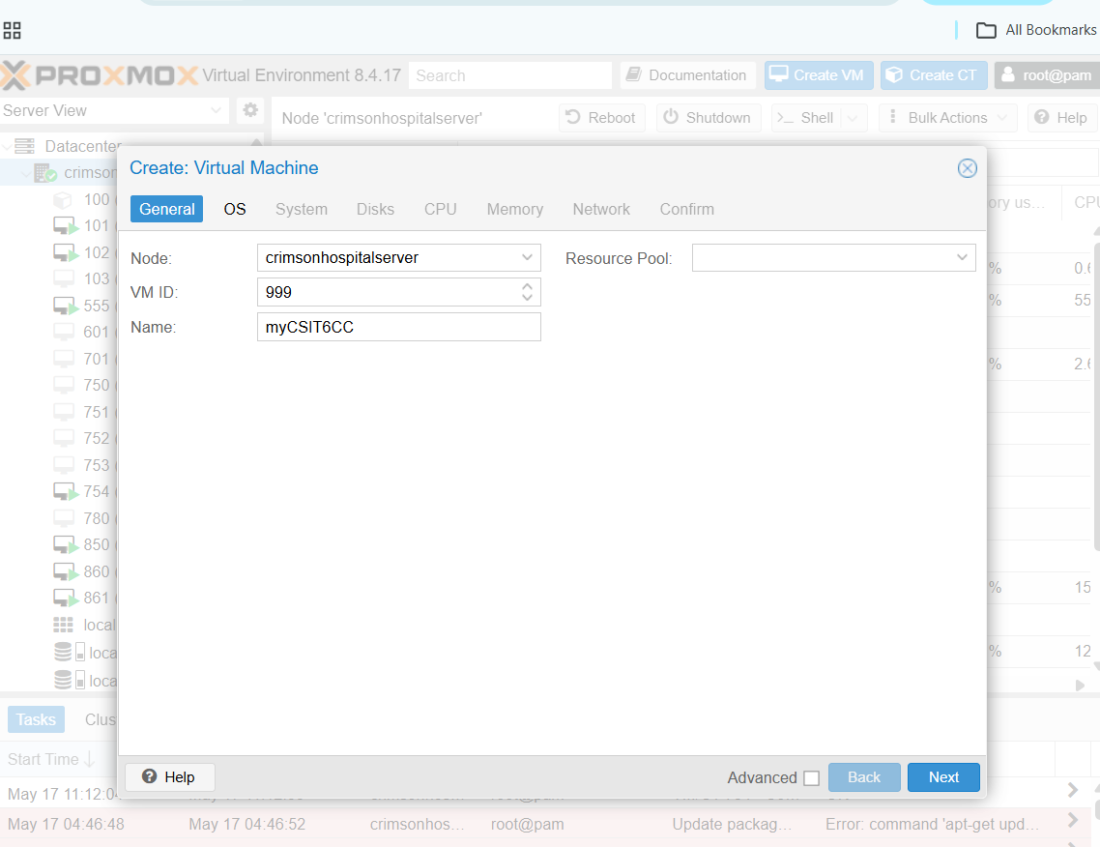

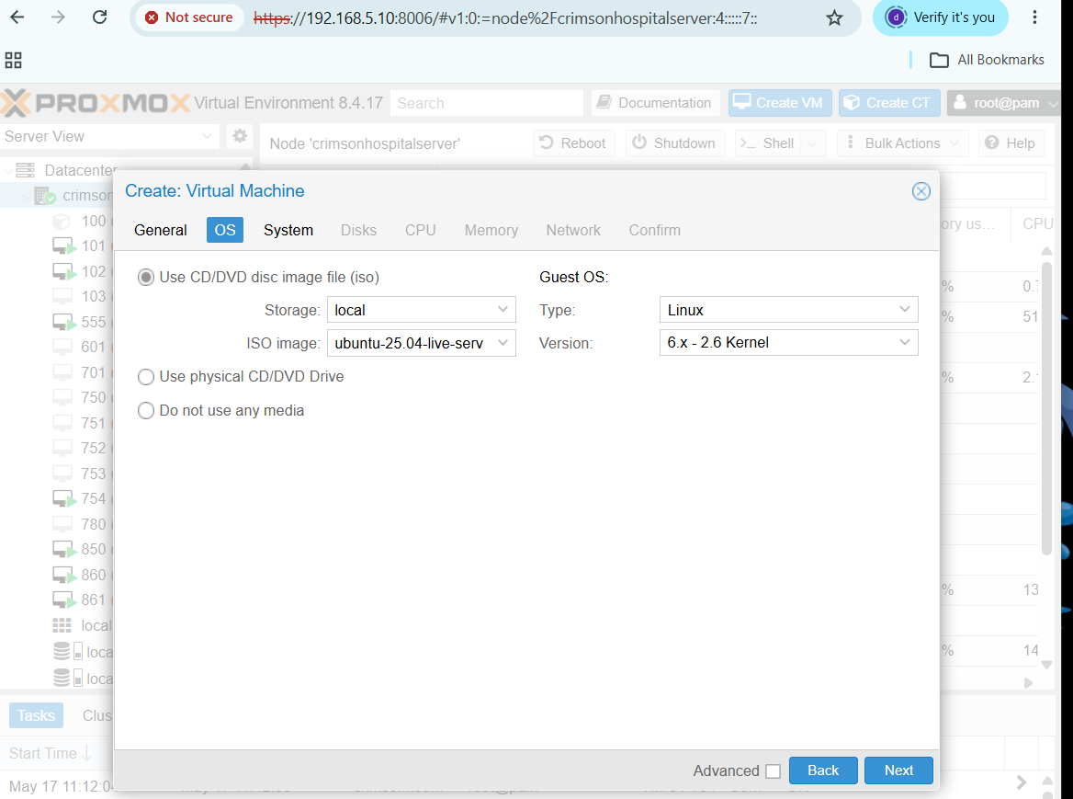

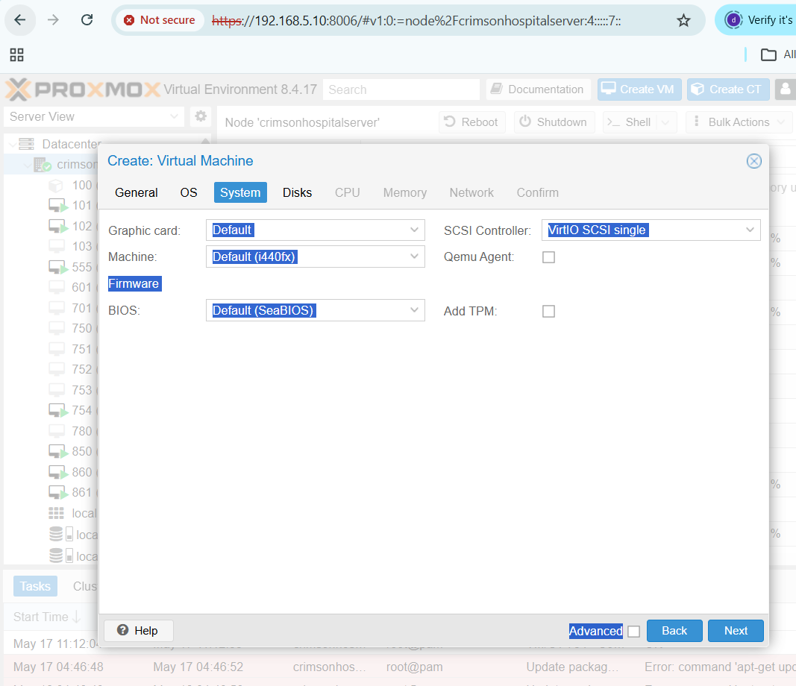
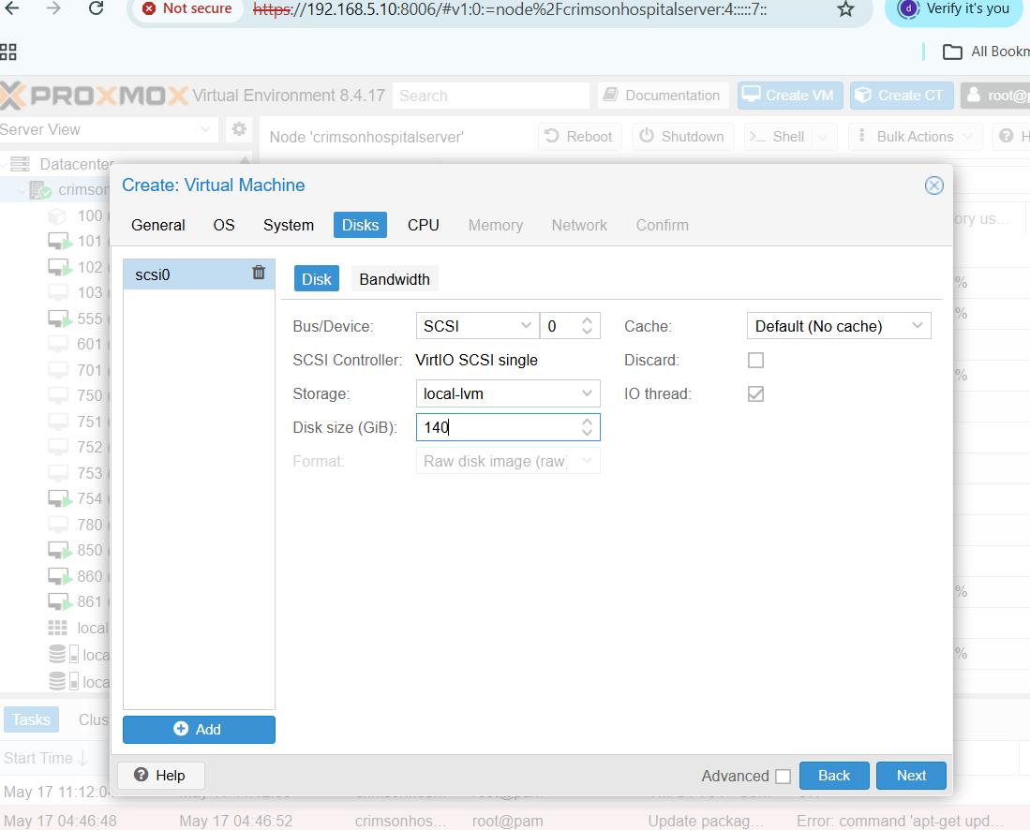

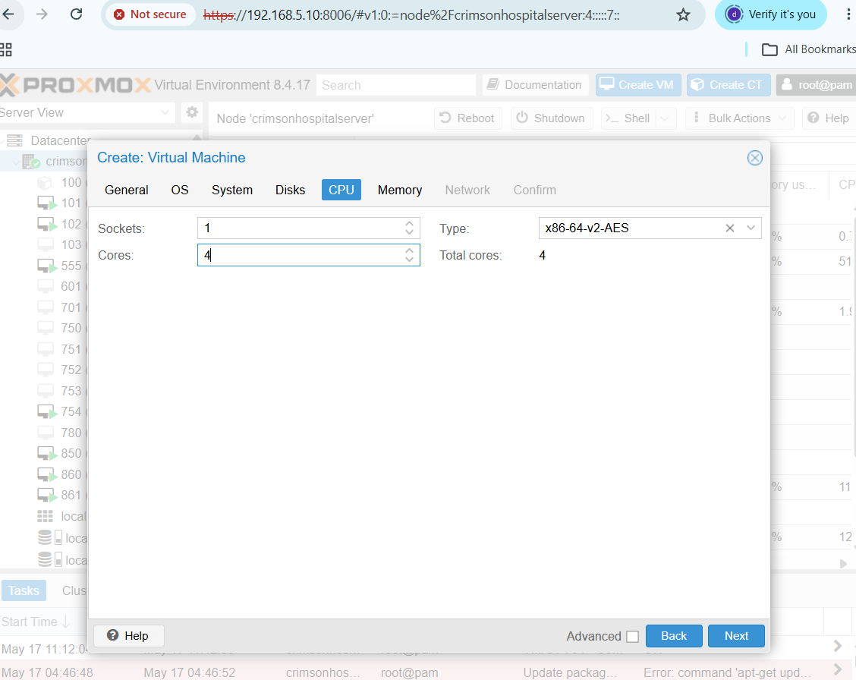

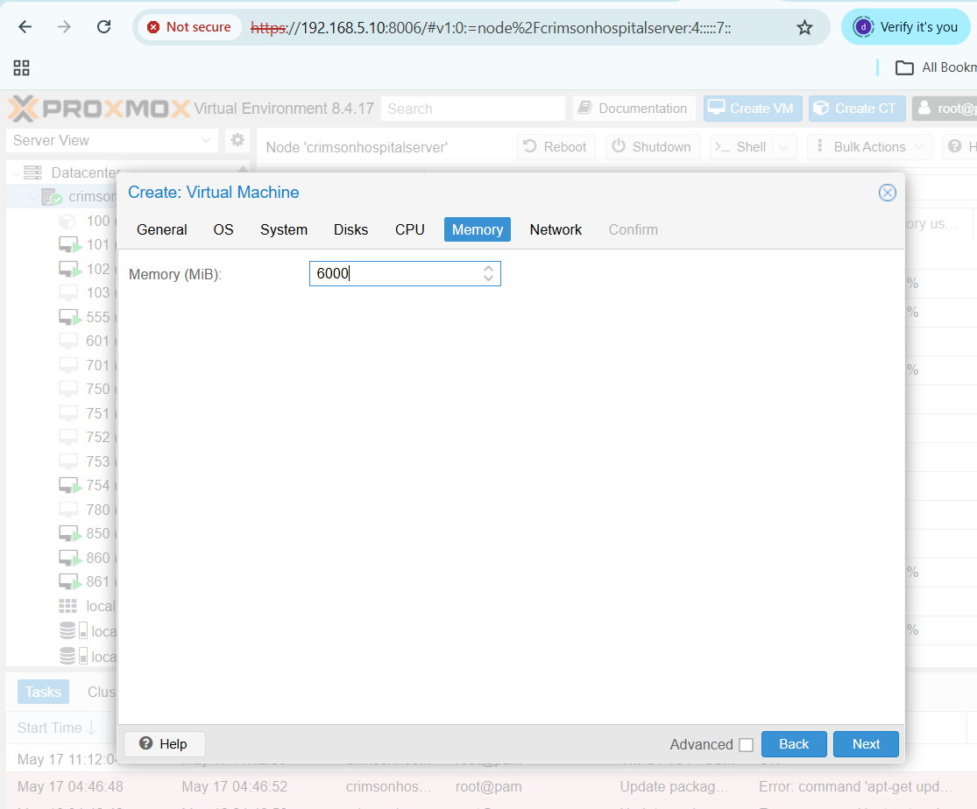

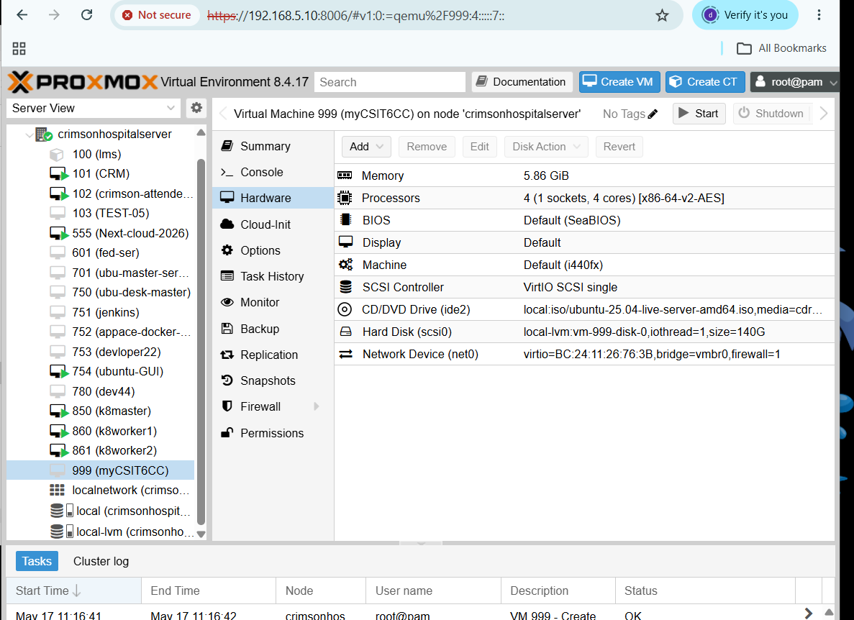

. 5.6 Introduction to containerization

Meaning of Containerization
Containerization is a technology that packages an application and its required dependencies together so that it can run consistently in different environments.

A container includes:
. Application code
. Libraries
. Dependencies
. Runtime environment
. Configuration files
But unlike a VM, a container does not include a full guest operating system.
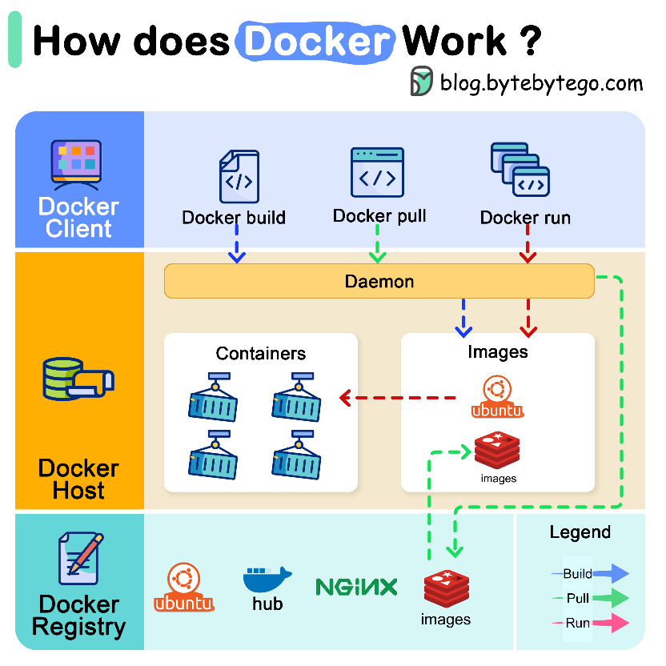

Simple Example
Suppose a Python web application needs:
. Python 3.11
. Flask
. Pandas
. Nginx
. Specific environment variables
Instead of installing these manually on every computer, we package them into a container.
Then the same container can run on:
. Developer laptop
. Testing server
. Production server
. Cloud platform

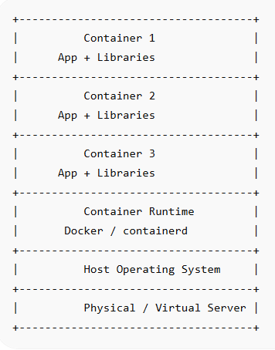
Containerization Architecture

Popular Container Tools
. Docker
. Podman
. containerd
. Kubernetes
. OpenShift



Docker Practical Example
Goal
Run a simple web server using Docker.

A. Docker Installation on Ubuntu
sudo apt update
sudo apt install docker.io -y
sudo systemctl start docker
sudo systemctl enable docker
docker --version

B. Run Hello World Container
sudo docker run hello-world
This checks whether Docker is installed correctly.
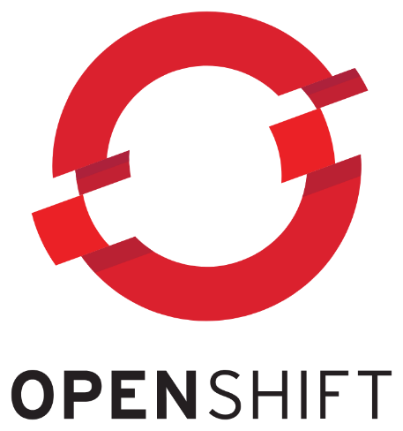

C. Run Nginx Web Server Container
sudo docker run -d -p 8080:80 --name my-nginx nginx
Now open in browser:
http://localhost:8080
Or from another computer:
http://SERVER-IP:8080

D. Check Running Containers
sudo docker ps

E. Stop Container
sudo docker stop my-nginx

F. Start Container Again
sudo docker start my-nginx

G. Remove Container
sudo docker rm my-nginx

Docker Practical: Create Own Web Page
Step 1: Create Project Folder
mkdir cloud-demo
cd cloud-demo

Step 2: Create HTML File
nano index.html
Paste:
<!DOCTYPE html>
<html>
<head>
<title>Cloud Computing Demo</title>
</head>
<body>
<h1>Hello World! Welcome to Cloud Computing</h1>
<p>This page is running inside a Docker container.</p>
</body>
</html>
Save the file.

Step 3: Create Dockerfile
nano Dockerfile
Paste:
FROM nginx:latest
COPY index.html /usr/share/nginx/html/index.html

Step 4: Build Docker Image
sudo docker build -t cloud-demo-web .

Step 5: Run Container
sudo docker run -d -p 8081:80 --name cloud-web cloud-demo-web
Open:
http://localhost:8081

Step 6: View Logs
sudo docker logs cloud-web

Step 7: Remove
sudo docker stop cloud-web
sudo docker rm cloud-web

Windows Docker Basic Commands
After installing Docker Desktop on Windows, open PowerShell:
docker --version
docker run hello-world
docker run -d -p 8080:80 --name win-nginx nginx
docker ps
docker stop win-nginx
docker rm win-nginx
Open browser:
http://localhost:8080

. 5.7 Virtual Machine vs Container
Basic Difference
A virtual machine virtualizes hardware.
A container virtualizes the operating system environment.

VM vs Container Table
Feature | Virtual Machine | Container
Virtualizes | Hardware | Operating system
OS | Each VM has full OS | Shares host OS kernel
Size | Large | Small
Startup time | Slow | Fast
Performance | More overhead | Lightweight
Isolation | Strong | Process-level isolation
Portability | Medium | High
Boot time | Minutes | Seconds
Example tools | VMware, VirtualBox, KVM | Docker, Podman, Kubernetes
Best for | Full OS environments | Microservices and apps
Data-Based Comparison
Assume one physical server has:
Resource | Capacity
CPU | 16 cores
RAM | 64 GB
Storage | 1 TB

Scenario A: Virtual Machines
Each VM uses:
CPU = 2 cores
RAM = 8 GB
Storage = 80 GB
Maximum VMs based on RAM:
64 GB ÷ 8 GB = 8 VMs
Maximum VMs based on CPU:
16 cores ÷ 2 cores = 8 VMs
Maximum VMs based on storage:
1000 GB ÷ 80 GB = 12 VMs approximately
So practical maximum:
8 VMs

Scenario B: Containers
Each container uses:
CPU = 0.5 core
RAM = 512 MB
Storage = 2 GB
RAM calculation:
64 GB = 65536 MB
65536 MB ÷ 512 MB = 128 containers
CPU calculation:
16 cores ÷ 0.5 core = 32 containers
Storage calculation:
1000 GB ÷ 2 GB = 500 containers
So practical maximum based on CPU:
32 containers

Interpretation
On the same server:
Technology | Approximate Capacity
Virtual Machine | 8 VMs
Container | 32 containers
Containers are more lightweight than VMs.
https://github.com/sanjeevlcc/notes_2081/blob/main/Artificial%20intelligence/Cloud%20Computing_2026/Notes_Blue/Unit%201/Lab5_Unit5_Docker_on_Power%20.txt

. 5.8 Introduction to serverless computing

Meaning of Serverless Computing
Serverless computing is a cloud computing model where developers write and deploy code without managing servers.
The cloud provider automatically handles:
. Server provisioning
. Scaling
. Runtime
. Availability
. Infrastructure management
The term serverless does not mean there is no server. It means the user does not manage the server.

Simple Example
A student uploads a photo to a website.
Automatically:
. A function is triggered
. The image is resized
. A thumbnail is created
. The resized image is stored
The developer only writes the function logic. The cloud provider manages the infrastructure.

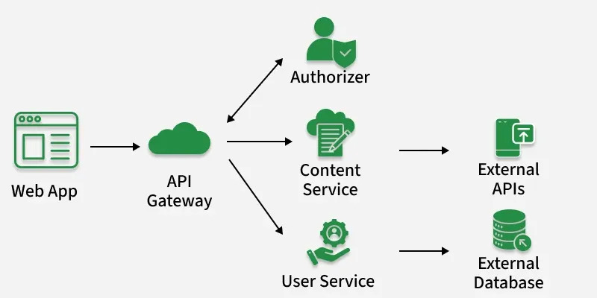
Serverless Platforms
. AWS Lambda
. Azure Functions
. Google Cloud Functions
. Cloudflare Workers
. Vercel Functions
. Netlify Functions

Serverless Architecture
User Action / Event
↓
Cloud Event Trigger
↓
Serverless Function
↓
Processing
↓
Output / Response

Benefits of Serverless
. No server management
. Automatic scaling
. Pay only when function runs
. Fast development
. Good for event-based tasks

Challenges of Serverless
. Cold start delay
. Limited execution time
. Vendor lock-in
. Debugging can be difficult
. Not suitable for all applications

Simple Serverless Example Concept
Use Case: Online Admission Form
When a student submits a form:
Event: Form submitted
Function:
. Validate data
. Save to database
. Send confirmation email
. Notify admin
The function runs only when the event occurs.

. 5.9 Event-driven functions

Meaning
Event-driven functions are functions that run automatically when a specific event occurs.
They are commonly used in serverless computing.

What is an Event?
An event is an action or change in the system.
Examples:
. File uploaded
. Form submitted
. Payment completed
. Database record added
. Sensor sends data
. User logs in
. Message received

Event-Driven Function Flow
Event Occurs
↓
Trigger Activates
↓
Function Executes
↓
Result is Generated

Examples of Event-Driven Functions
Event | Function Action
Image uploaded | Resize image
Payment completed | Send receipt
Student submits form | Send confirmation email
New user registers | Create user profile
CPU usage high | Send alert
IoT sensor sends temperature | Store reading in database

Data-Based Example: Temperature Alert
A cloud function receives sensor data from a server room.
Time | Temperature
10:00 AM | 24°C
10:05 AM | 26°C
10:10 AM | 30°C
10:15 AM | 35°C
10:20 AM | 38°C
Condition:
If temperature > 35°C, send alert.
At 10:20 AM, temperature is 38°C.
Result:
Alert: Server room temperature is high.

Python Example: Event-Driven Function Logic
def temperature_alert(event):
temperature = event["temperature"]
if temperature > 35:
return "Alert: Temperature is high!"
else:
return "Temperature is normal."
event_data = {
"temperature": 38
}
result = temperature_alert(event_data)
print(result)
Output:
Alert: Temperature is high!

https://github.com/sanjeevlcc/notes_2081/blob/main/Artificial%20intelligence/Cloud%20Computing_2026/Notes_Blue/Unit%201/Lab6_Unit5_Serverless%20and%20eventFunctions%20.txt

. 5.10 Load balancing concepts

Meaning of Load Balancing
Load balancing is the process of distributing incoming network traffic across multiple servers.
It prevents one server from becoming overloaded.
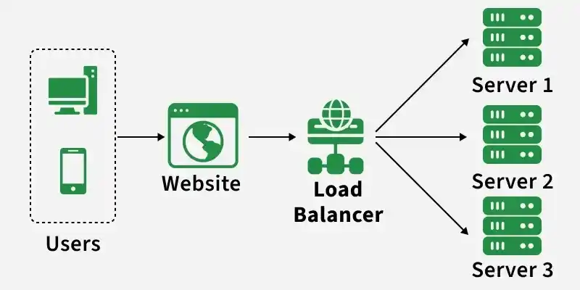

Simple Example
A website receives 9,000 user requests.
There are 3 servers.
Without load balancing:
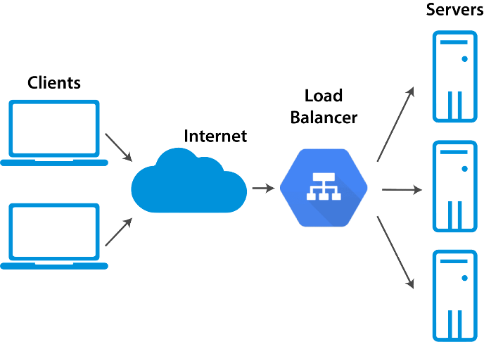
Server 1 may get too many requests.
Server 2 and Server 3 may remain underused.

With load balancing:
Server | Requests
Server 1 | 3,000
Server 2 | 3,000
Server 3 | 3,000

Load Balancing Diagram
Users
↓
Load Balancer
↓ ↓ ↓
Server1 Server2 Server3

Benefits of Load Balancing
. Improves performance
. Prevents server overload
. Increases availability
. Supports scalability
. Improves user experience

Common Load Balancing Algorithms
1. Round Robin
Requests are sent one by one to each server in order.
Example:
Request 1 → Server 1
Request 2 → Server 2
Request 3 → Server 3
Request 4 → Server 1

2. Least Connections
Request is sent to the server with the fewest active connections.
Example:
Server | Active Connections
Server 1 | 30
Server 2 | 10
Server 3 | 25
New request goes to:
Server 2

3. IP Hash
The user’s IP address decides which server will handle the request.
Useful when the same user should connect to the same server.

4. Weighted Load Balancing
More powerful servers receive more traffic.
Example:
Server | Capacity | Weight
Server 1 | High | 5
Server 2 | Medium | 3
Server 3 | Low | 1
Server 1 receives more requests than Server 3.

Practical Nginx Load Balancing Example
Assume we have three application servers:
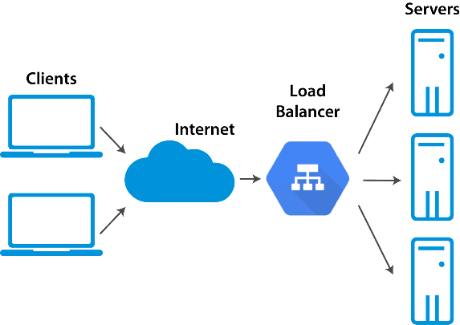
Server 1: 192.168.1.101:8080
Server 2: 192.168.1.102:8080
Server 3: 192.168.1.103:8080

Nginx configuration:
http {
upstream backend_servers {
server 192.168.1.101:8080;
server 192.168.1.102:8080;
server 192.168.1.103:8080;
}
server {
listen 80;
location / {
proxy_pass http://backend_servers;
}
}
}

Docker Compose Load Balancing Demonstration
Goal
Run multiple web containers and balance traffic using Nginx.

Folder Structure
load-balance-demo/
│
├── docker-compose.yml
└── nginx.conf

docker-compose.yml
version: "3.8"
services:
web1:
image: nginx
container_name: web1
volumes:
- ./web1.html:/usr/share/nginx/html/index.html
web2:
image: nginx
container_name: web2
volumes:
- ./web2.html:/usr/share/nginx/html/index.html
web3:
image: nginx
container_name: web3
volumes:
- ./web3.html:/usr/share/nginx/html/index.html
loadbalancer:
image: nginx
container_name: loadbalancer
ports:
- "8080:80"
volumes:
- ./nginx.conf:/etc/nginx/nginx.conf
depends_on:
- web1
- web2
- web3

nginx.conf
events {}
http {
upstream web_servers {
server web1:80;
server web2:80;
server web3:80;
}
server {
listen 80;
location / {
proxy_pass http://web_servers;
}
}
}

Create HTML Files
echo "<h1>This is Web Server 1</h1>" > web1.html
echo "<h1>This is Web Server 2</h1>" > web2.html
echo "<h1>This is Web Server 3</h1>" > web3.html

Run
docker compose up -d
Open:
http://localhost:8080

Refresh multiple times to observe response from different backend servers.

Stop
docker compose down

. 5.11 Serverless vs containerized workloads

Meaning of Containerized Workload
A containerized workload is an application running inside containers.
Example:
. Docker container
. Kubernetes pod
. Microservice application

Meaning of Serverless Workload
A serverless workload is code that runs only when triggered by an event.
Example:
. AWS Lambda function
. Azure Function
. Google Cloud Function

Serverless vs Containerized Workloads
Feature | Serverless | Containerized
Server management | Managed by provider | User manages container environment
Runtime | Runs on event | Runs continuously
Scaling | Automatic | Manual or Kubernetes-based
Cost | Pay per execution | Pay for running resources
Startup | May have cold start | Usually always running
Control | Less control | More control
Best for | Short event-based tasks | Long-running applications
Examples | AWS Lambda | Docker, Kubernetes

When to Use Serverless
Use serverless when:
. Task is event-based
. Function runs for short time
. Traffic is unpredictable
. You want minimal server management
. You need automatic scaling
Examples
. Sending email after form submission
. Resizing uploaded image
. Processing payment notification
. Running scheduled backup task
. Sending alert when CPU is high

When to Use Containers
Use containers when:
. Application runs continuously
. You need more control
. You have microservices
. You need custom runtime
. Application has complex dependencies
Examples
. Web application
. API server
. Database service
. ERP system
. Learning Management System
. AI model serving application

PAPER/ CASE
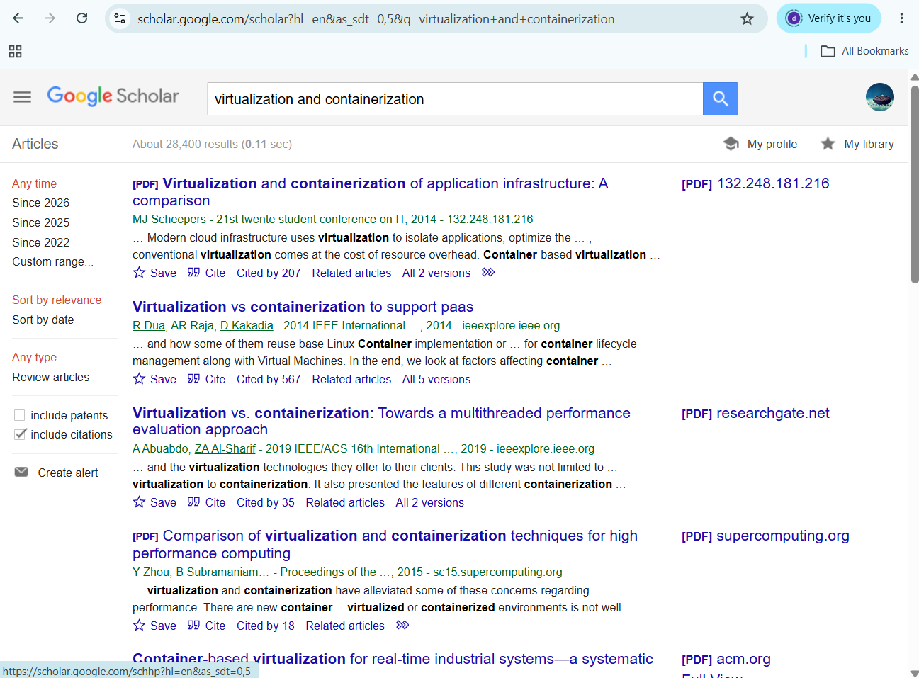

- http://132.248.181.216/DC/MaquinasVirtuales/CursoMaquinasVirtuales/VirtualizacionEnLinuxCon-Containers/539ae779eb69a.pdf
- https://sc15.supercomputing.org/sites/all/themes/SC15images/tech_poster/poster_files/post239s2-file3.pdf
- https://dl.acm.org/doi/pdf/10.1145/3617591
- https://elibrary.tucl.edu.np/JQ99OgQIizUxyjI9nB0on9OyLkqsGIf4/api/core/bitstreams/d8137104-fa40-48e7-883f-a951e03e1bb2/content

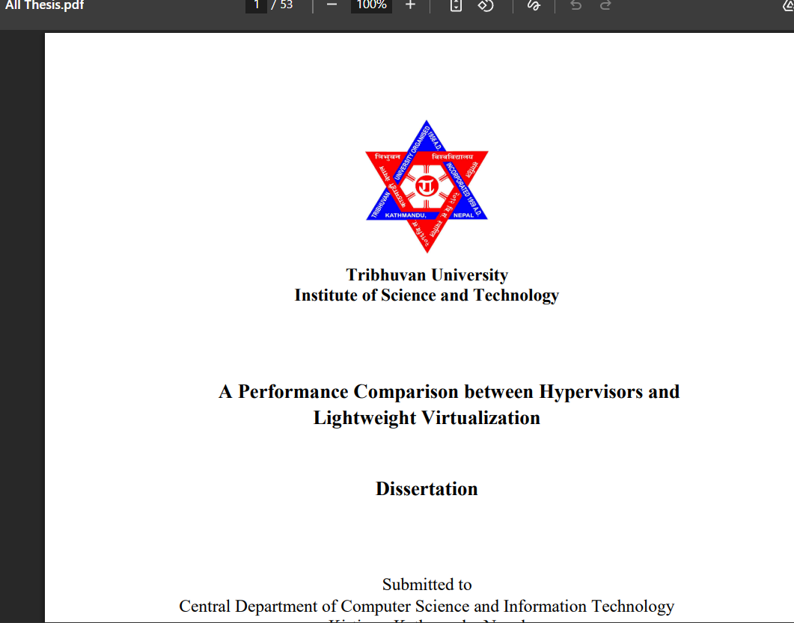
https://elibrary.tucl.edu.np/JQ99OgQIizUxyjI9nB0on9OyLkqsGIf4/api/core/bitstreams/d8137104-fa40-48e7-883f-a951e03e1bb2/content

Basic Questions
- What is virtualization, and why is it considered a foundation technology for cloud computing?
- What are the major differences between hypervisor-based virtualization and container-based lightweight virtualization?
- How do KVM and LXC/LXD differ in terms of architecture, resource sharing, and guest operating system support?
- What roles do namespaces and control groups play in Linux container-based virtualization?
- Which benchmarking tools were used in the thesis to measure CPU, memory, disk I/O, and web server response time?
Analytical Questions
- Why does lightweight virtualization generally produce lower overhead than hypervisor-based virtualization?
- How does sharing the host kernel affect the performance and limitations of Linux containers?
- Why might LXC/LXD outperform KVM in CPU, memory, disk I/O, and Apache web server response time?
- How does the use of qcow2 disk image format in KVM affect disk I/O performance compared with LXC?
- What does lower standard deviation indicate in the performance comparison between KVM and LXC/LXD?

